# **22. Rapid Spanning Tree Protocol (RSTP)**

## **Comparison of STP Versions (Standard vs. Cisco)**

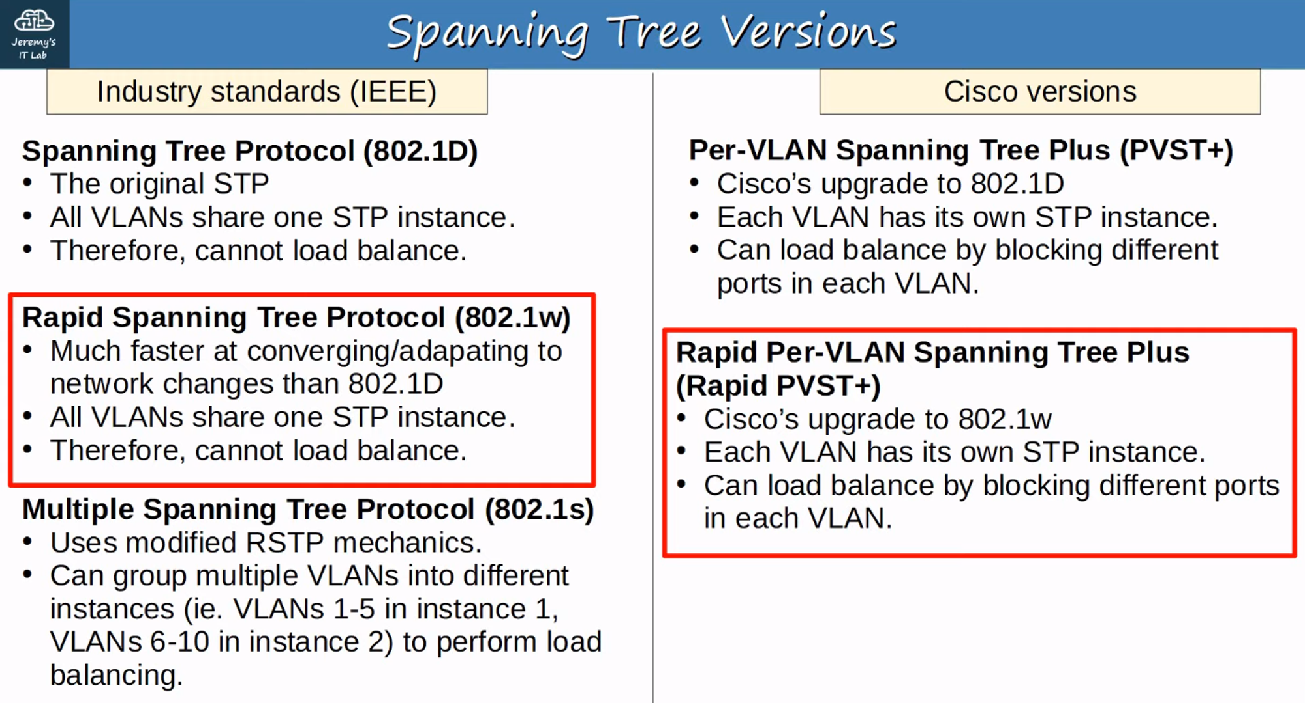

* **802.1w** is the main focus for most use cases.
* **MSTP (802.1s)** is suitable for **very large networks**.

## **What is Rapid Per-VLAN Spanning Tree Plus?**

RSTP is not a time-based algorithm like **802.1D**.  
 It improves upon the 30+ seconds that **802.1D** takes to move a link to forwarding by using a new handshake mechanism, allowing ports to move directly to forwarding.

## **Similarities Between STP and RSTP**

* Both **block specific ports** to prevent Layer 2 loops.
* Both elect a **Root Bridge**, **Root Ports**, and **Designated Ports** using the same rules.

## **Differences Between STP and RSTP**

### **Port Costs**

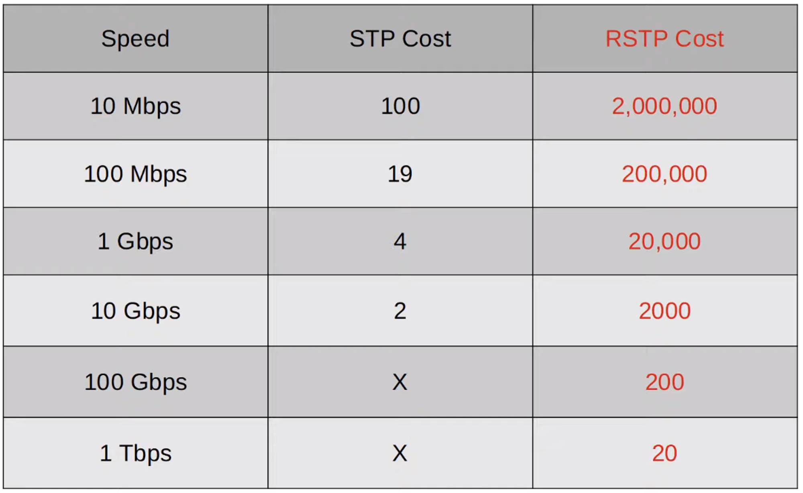 **(Study and memorize the port costs for both STP and RSTP.)**

### **RSTP Port States**

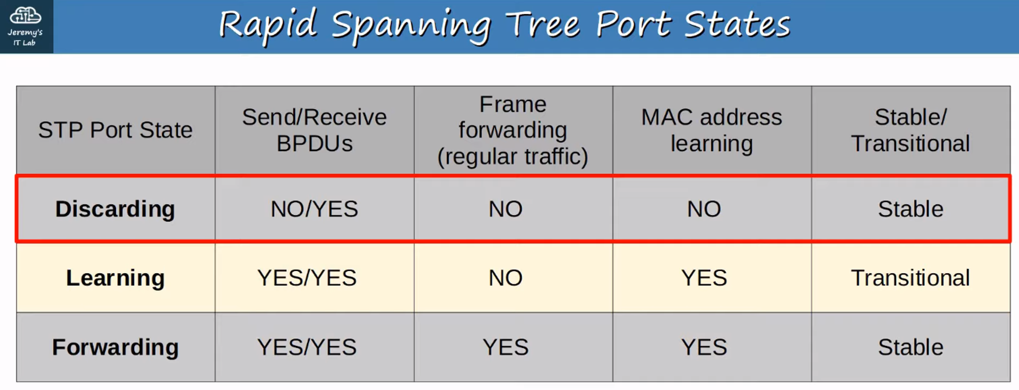

* **Discarding State:**
  + Port administratively disabled (shutdown command).
  + Port enabled but blocking traffic to prevent loops.

## **RSTP Roles**

### **Root Port**

* Unchanged from STP.
* Closest port to the **Root Bridge** becomes the **Root Port**.
* **Root Bridge** itself does not have a **Root Port**.

### **Designated Port**

* Unchanged from STP.
* The port on a segment (collision domain) that sends the best BPDU becomes the **Designated Port**.

### **Alternate Port**

* Discarding port that receives a **superior BPDU** from another switch.
* Functions as a **backup to the Root Port**.

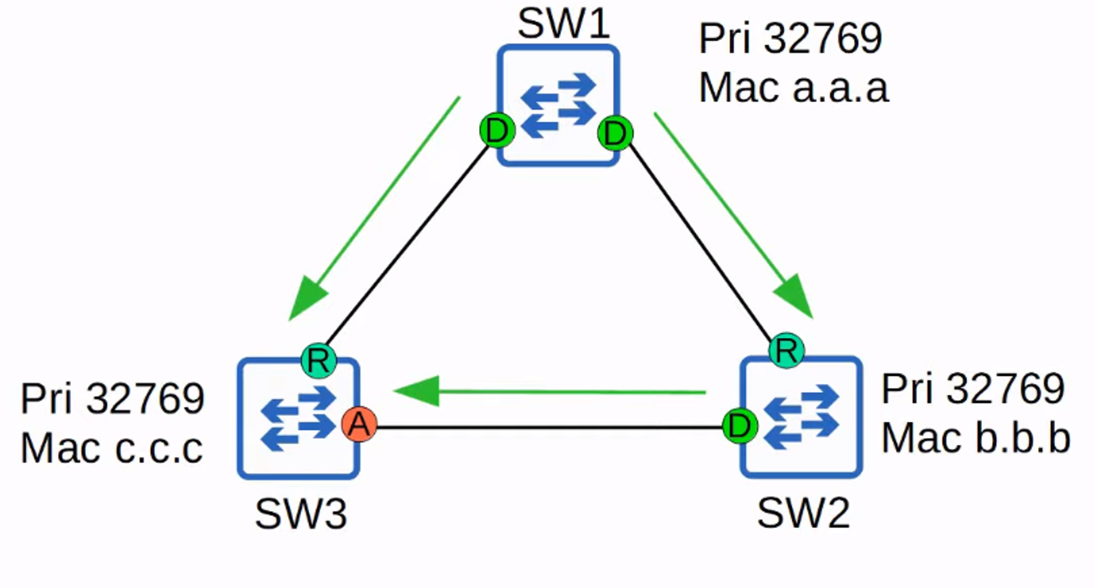

💡 **UplinkFast** functionality is built into RSTP, allowing immediate forwarding upon Root Port failure.

### **Backup Port**

* Discarding port that receives a **superior BPDU** from another interface on the same switch.
* Occurs when two interfaces connect to the **same collision domain (via a hub)**.

💡 Hubs are rare in modern networks, so encountering a **Backup Port** is unlikely.

## **RSTP and STP Compatibility**

* RSTP is **backward-compatible** with classic STP.
* Interfaces on RSTP switches connected to STP-enabled switches will operate in **classic STP mode**.

## **BPDU Differences**

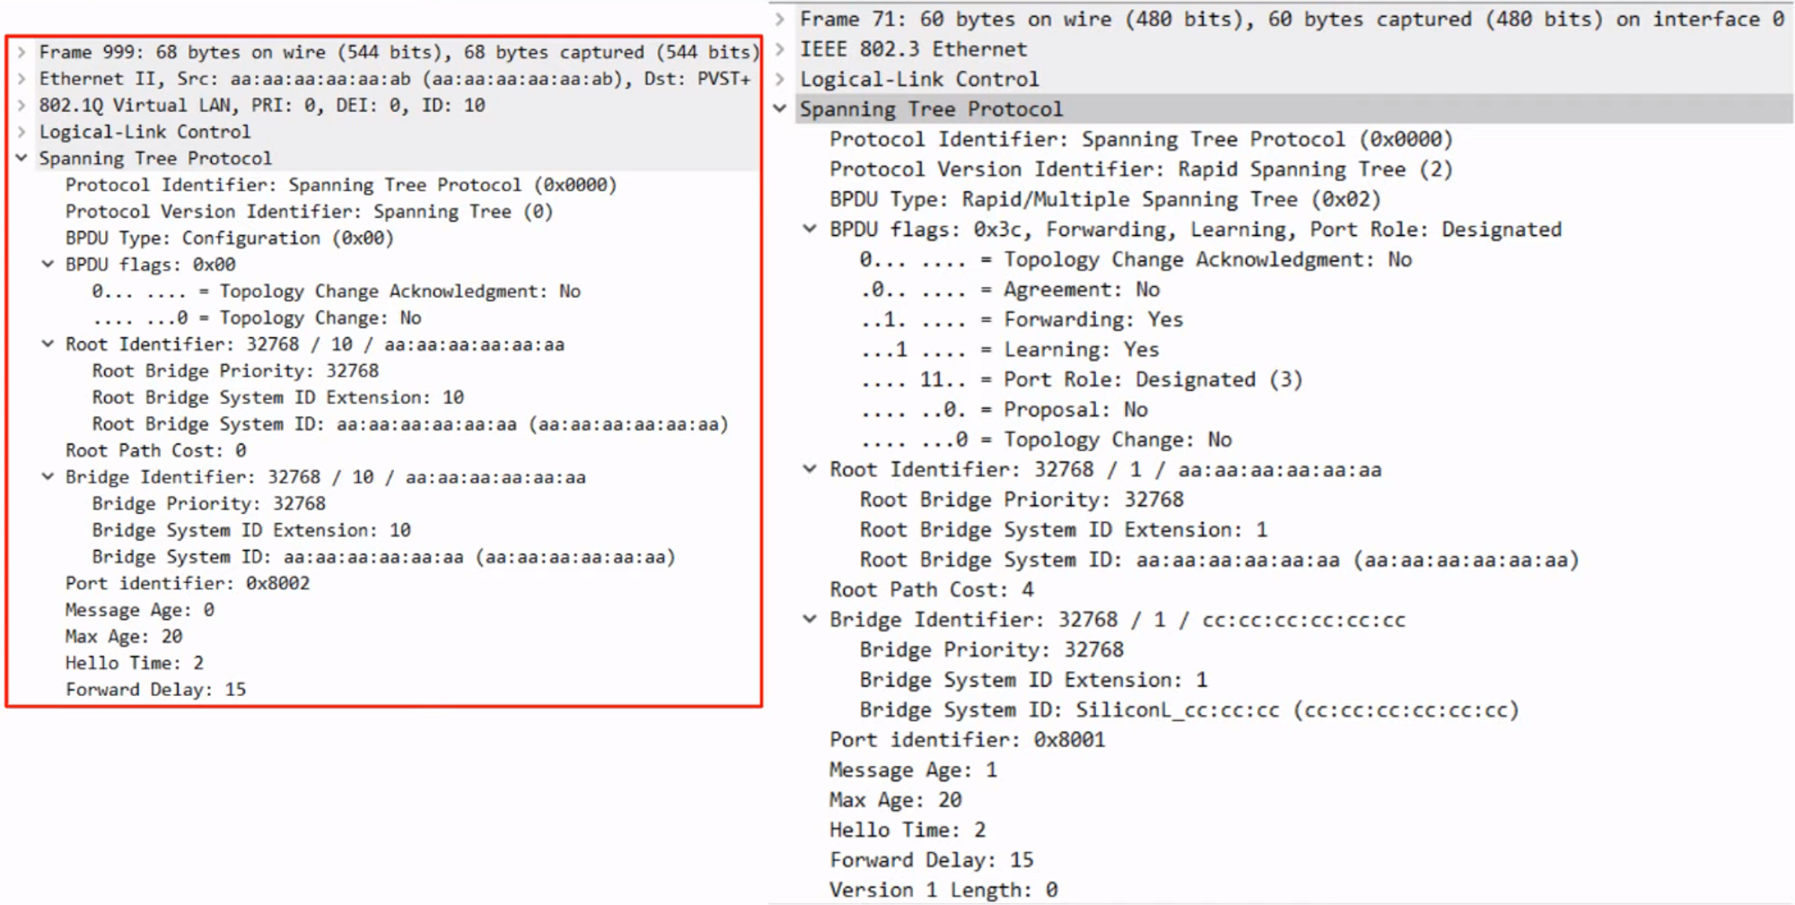

* **Classic STP BPDUs** originate only from the Root Bridge, while other switches forward them.
* **RSTP BPDUs** are originated by all switches from their Designated Ports.

## **RSTP Link Types**

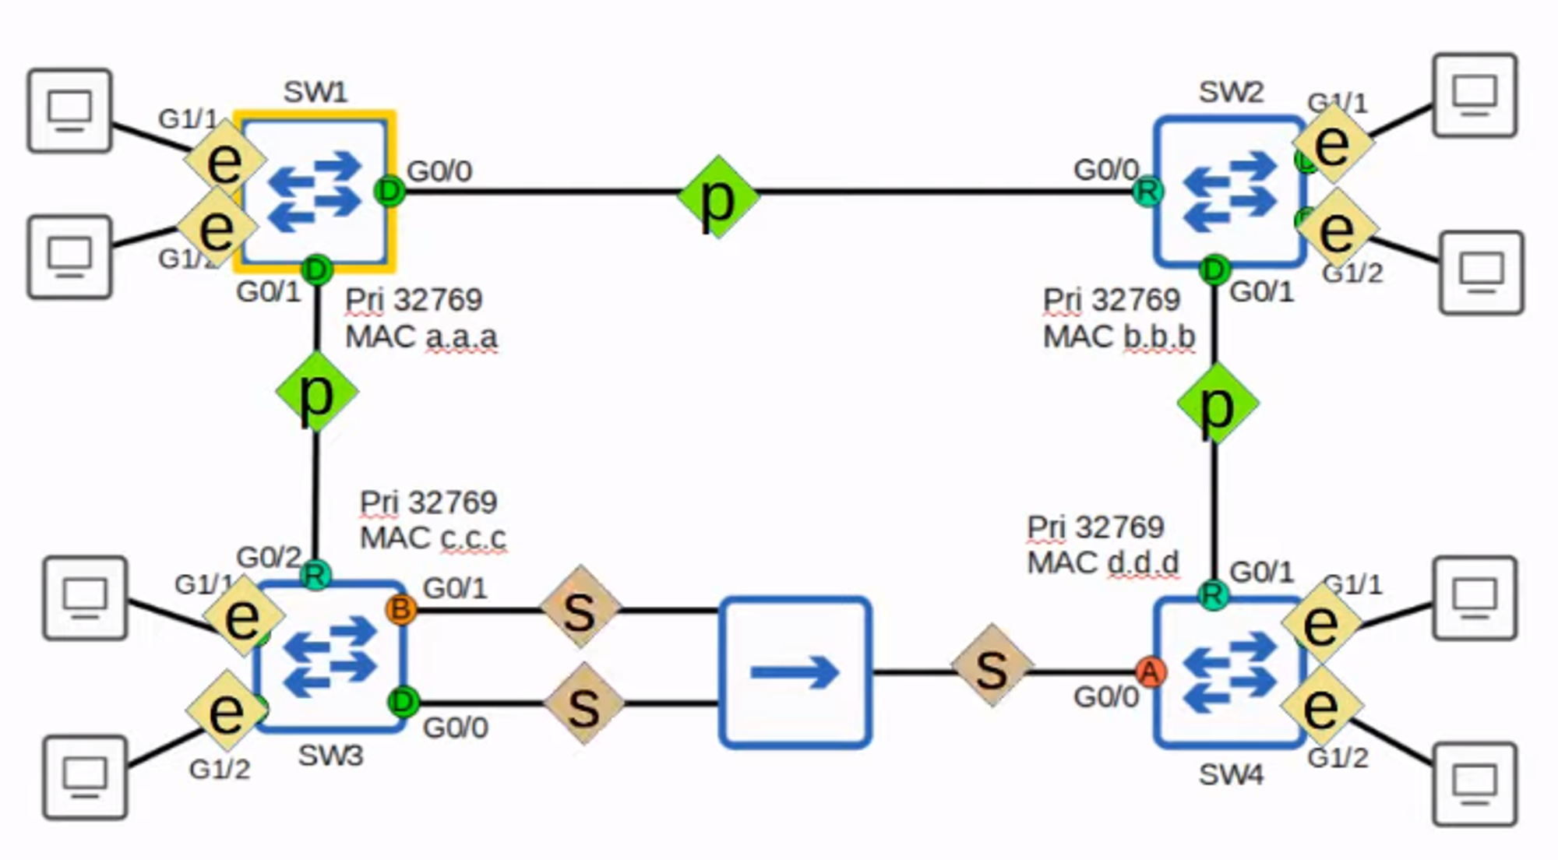

1. **Edge Ports:**
   * Connected to end hosts.
   * No loop risk, so they move directly to forwarding (similar to PortFast).
   * **Command:** spanning-tree portfast.
2. **Point-to-Point Ports:**
   * Directly connected to another switch (full-duplex).
   * **Command (optional):** spanning-tree link-type point-to-point.
3. **Shared Ports:**
   * Connect to other switches via a hub (half-duplex).
   * **Command (optional):** spanning-tree link-type shared.

### **Port Roles**

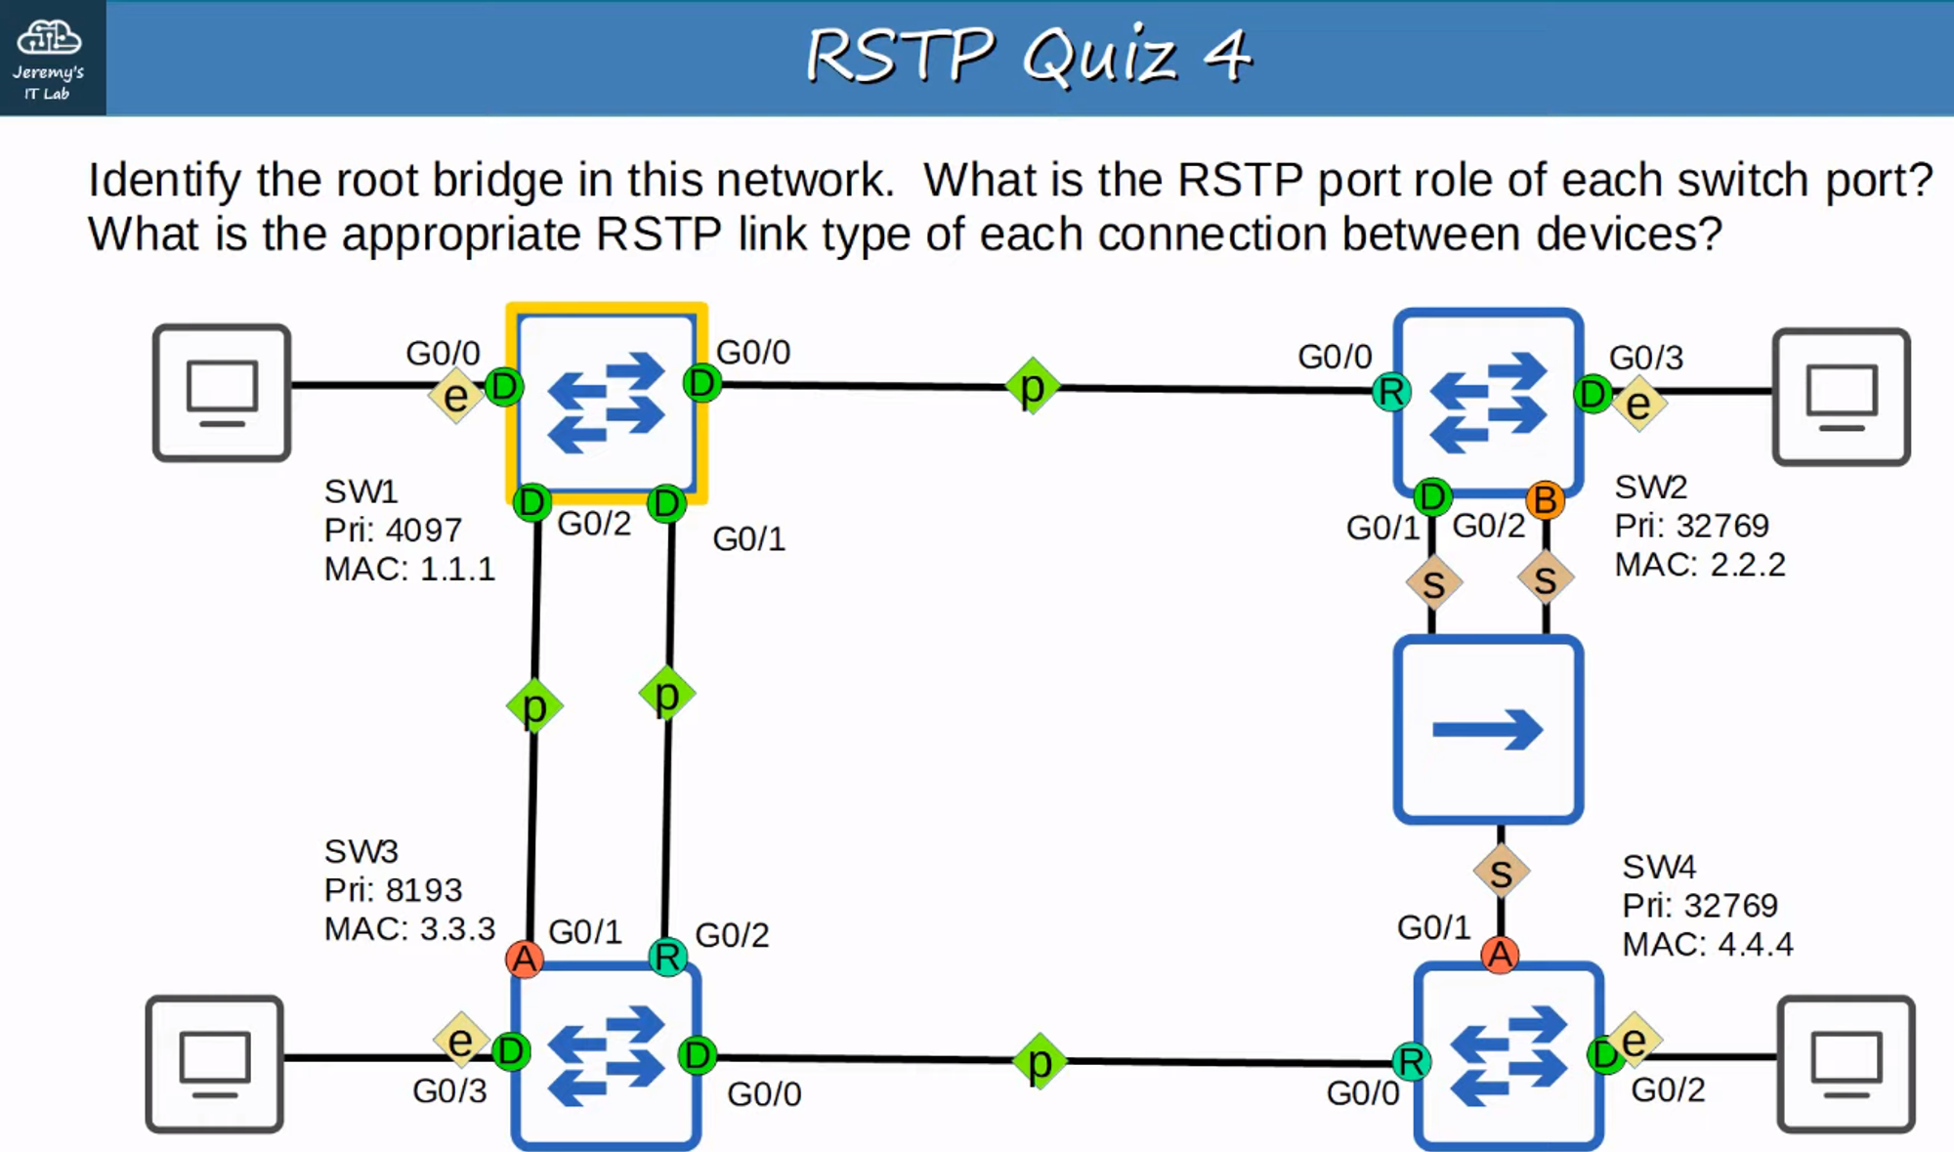

* **SW1 (Root Bridge):**
  + G0/0–G0/3: Designated
* **SW2:**
  + G0/0: Root Port
  + G0/1, G0/3: Designated Ports
  + G0/2: Backup Port
* **SW3:**
  + G0/0, G0/3: Designated Ports
  + G0/1: Alternate Port
  + G0/2: Root Port
* **SW4:**
  + G0/0: Root Port
  + G0/1: Alternate Port
  + G0/2: Designated Port

### **Link Types**

* Connections between switches = **Point-to-Point**.
* Connections to end hosts = **Edge**.
* Connections via a hub = **Shared**.